RESOLUTION NO.__________

RE: CERTIFICATE OF APPROPRIATENESS UNDER THE
PROVISIONS OF THE ACT OF THE PENNSYLVANIA
LEGISLATURE 1961, JUNE 13, P.L. 282 (53
SECTION 8004) AND BETHLEHEM ORDINANCE NO.
3952 AS AMENDED.

WHEREAS, it is proposed to demolish the unused chimney and replace roof area at 413 Vine Street.

NOW, THEREFORE, BE IT RESOLVED by the Council of the City of Bethlehem that a Certificate of Appropriateness is hereby granted for the work.

Sponsored by: (s)

(s)

ADOPTED BY COUNCIL THIS DAY OF

(s)
President of Council

ATTEST:

(s)
City Clerk

HISTORIC CONSERVATION COMMISSION

CASE # 560 – It is proposed to demolish the unused chimney and replace roof area at 413 Vine Street
OWNER/APPLICANT: Alan & Nancy Ann Finnegan / Tim Finnegan

The Commission upon motion by Mr. Evans seconded by Mr. Silvoy adopted the proposal that City Council issue a Certificate of Appropriateness for the proposed work described herein:
- The proposal to demolish the unused chimney and replace roof area at 413 Vine Street was presented by Tim Finnegan.
- The unused cinder block chimney is partially demolished and not part of the original structure. The entire chimney will be demolished as proposed.
- Care should be taken during demolition to preserve the wall material behind the chimney. If it is damage it should be replaced in-kind.
- The area behind the chimney will be painted to match the color of the rest of the siding.
- The roof area at the former chimney will be replaced with the same roofing material as the rest of the existing roof.
- The motion to approve the proposed work was unanimously approved.

CU: cu
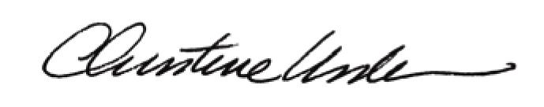

By:

Date of Meeting: August 17, 2015 Title: Historic Officer

